**Analysis for Computing Services Committee Survey at Syracuse University**

**Trishla Jain, Karthik Ramanathan**

**1. Introduction**

The University Faculty Senate's Computing Services Committee asked faculty and staff to respond to an online survey about campus computing services and technology. The survey ran from the end of September to mid-October 2022, with a response rate of nearly 30%. Most of the questions were Likert Scale questions (multiple choice ranging from agree to disagree), but also included several free text boxes. Like any survey, most people didn’t fill out all the sections involving text fields. Using text mining tools as our data analysis toolkit, our task is to understand which computing services are doing well and what are the areas of improvement. The results can then be reported back to the University Senate, who maintain Syracuse University’s computing resources.

**2. About the Data**

* 1. **Technologies list for feedback**

The technologies for which feedback was collected involved all kinds of tools or resources used by the faculty to teach students. They are as follows: MySlice, Wireless Network, Zoom, Teams, Blackboard, Kaltura, Teaching Tools, Assistive Tools, Accessibility Feedback, IT Challenges, Security, Playposit, Google Suite. Table X below has the list of user satisfaction rate.

**2.2 Data Collection**

The survey asks people if they use a service first. For a particular technology users respond to how satisfied they are with the resource using the following values - “Strongly Agree”, “Somewhat Agree”, “Agree”, “Strongly Disagree”, “Somewhat Disagree”, “Disagree”. Only the respondents who choose “Strongly Disagree”, “Somewhat Disagree”, “Disagree” in the previous section can see the “Dissatisfied Factor” sub-section, which is a text input field. Since the reasons for dissatisfaction were asked only to a subset of users, some technologies we have very little data to work with.

**3. Approach**

Given the fact that optional text boxes appeared in the survey only when someone was dissatisfied with a service, we have chosen to perform sentiment analysis for a technology only if there is sufficient feedback to build a model (by checking the count of non-null values for each technology/service). For the rest we have used text mining approaches such as word cloud, frequency distribution using count and TF-IDF, and cluster analysis using BERT to analyze the feedback. We created functions for word clouds, TF-IDF, BERT and sentiment analysis to ease our search for those services whose improvement might have the greatest positive impact on the work lives of our faculty.

**4. Analysis/Results**

In this section we focus on each technology/service, the rate of user satisfaction and the scope for improvement. While performing cluster analysis, positive feedback groups have been intentionally kept off the report to keep the report succinct and to align the report with the goal of the survey – identifying any shortcoming in the campus’s computing services.

**4.1 Wireless Network**

65% of the users were satisfied with the working of wireless network on-campus.

**4.1.A. Word Cloud**

Among the general feedback 'Spotty' is the word that stands out and among the sources of dissatisfaction the 'Connectivity' seems to be a problem.

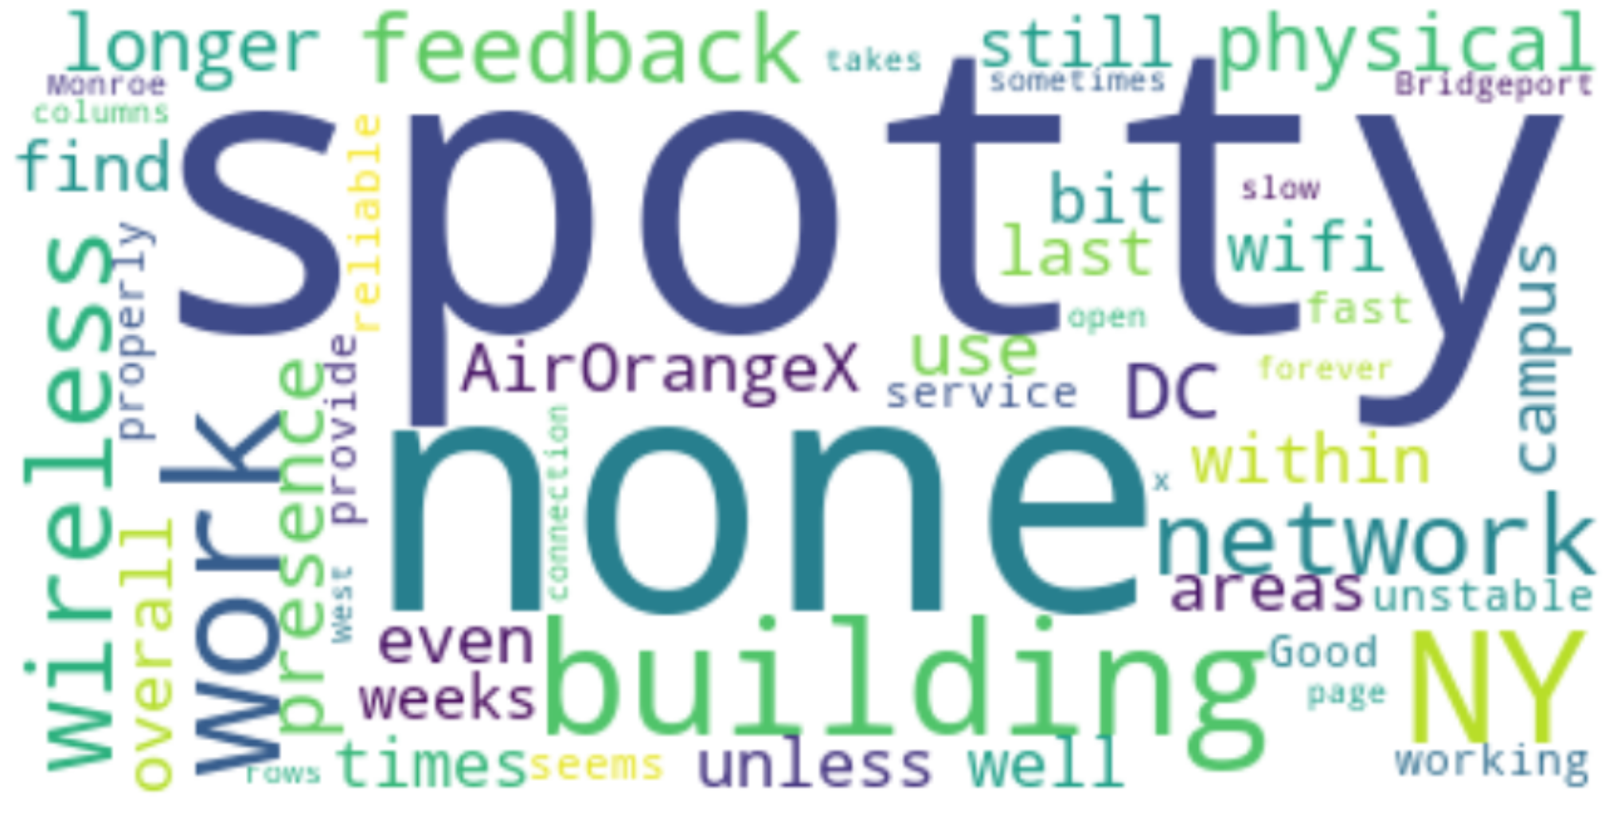  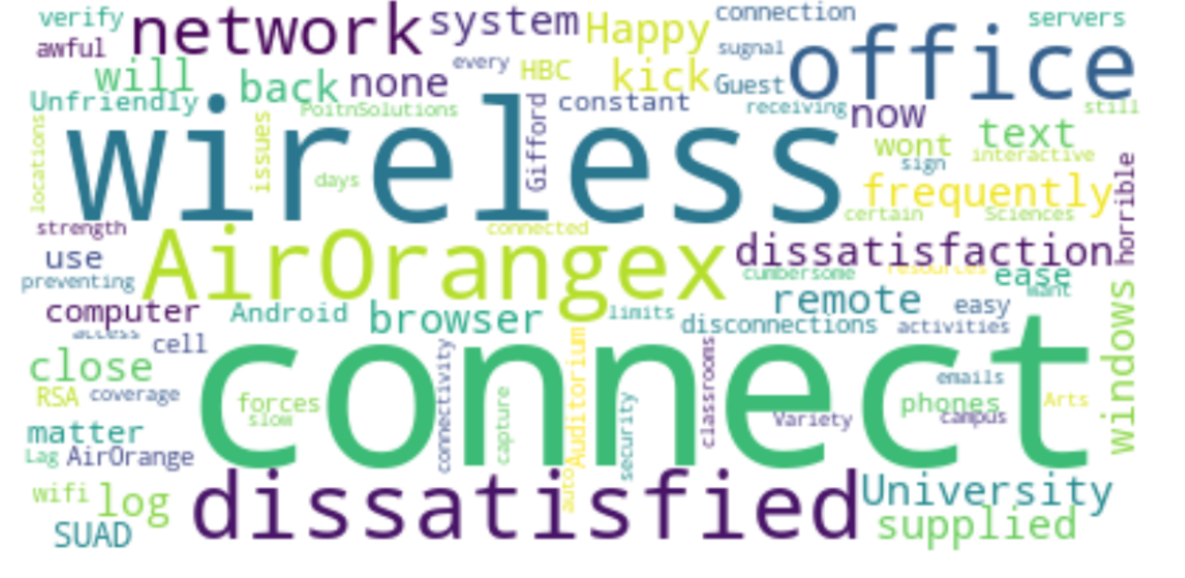

Fig 1: General Feedback - Wireless Network Fig 2: Dissatisfaction - Wireless Network

**4.1.B. Frequency Distribution and TF-IDF**

Analyzing the most common words in the ***wireless.network.feedback*** column by checking their frequency and using TF-IDF, the observation supports the inference from the word clouds. Spotty connectivity and network issues are the major concerns from users.

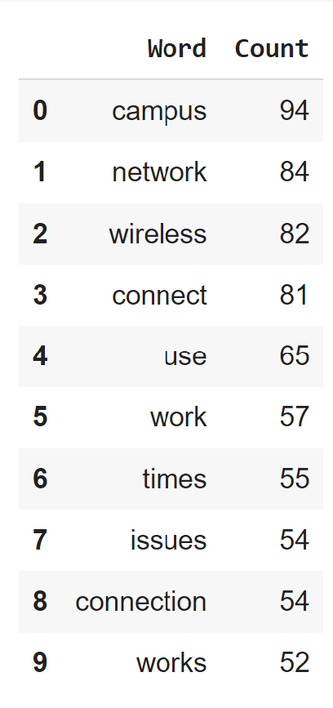 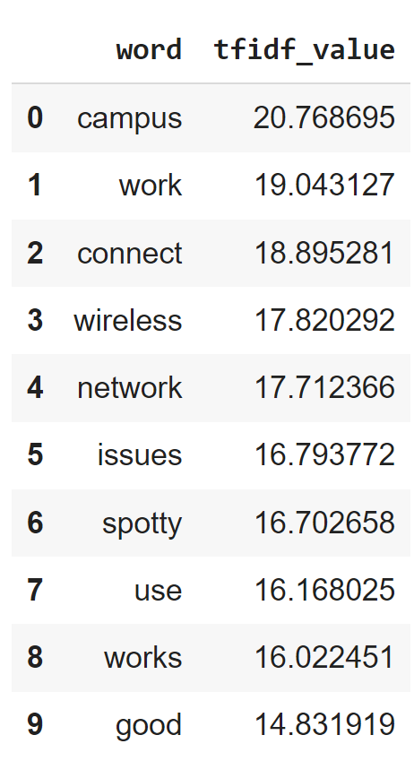

Fig 3: Frequency Distribution - Wireless Network Fig 4: TF-IDF - Wireless Network

**4.1.C. Topic Modelling**

|  |  |
| --- | --- |
| Cluster Name | Cluster Details |
| Login | Users seem to have issues logging into or connecting to the wireless network.  Eg- “"It kicks my phone off A LOT and constantly asks me to reauthenticate. When I do, it says 'bad password' and I'm 100% sure my password is fine. Kinda frustrating.” |
| Bandwidth | Users seem to be having issues connecting to the Wifi in certain areas of campus.  Eg- “I have had issues in the past, but I have a class in life sciences this semester, and I have had to print out my google doc prompts every class because I cannot count on the wifi.” |

Table 1 – Topic Modeling – Wireless Network

**4.2 MySlice**

73% of the users were satisfied with the working of MySlice

**4.2.A. Word Cloud**

Users seem to be having a hard time navigating the website and find it difficult to use. The other major complaint is the difficulty logging in and the repeated stale login issue.

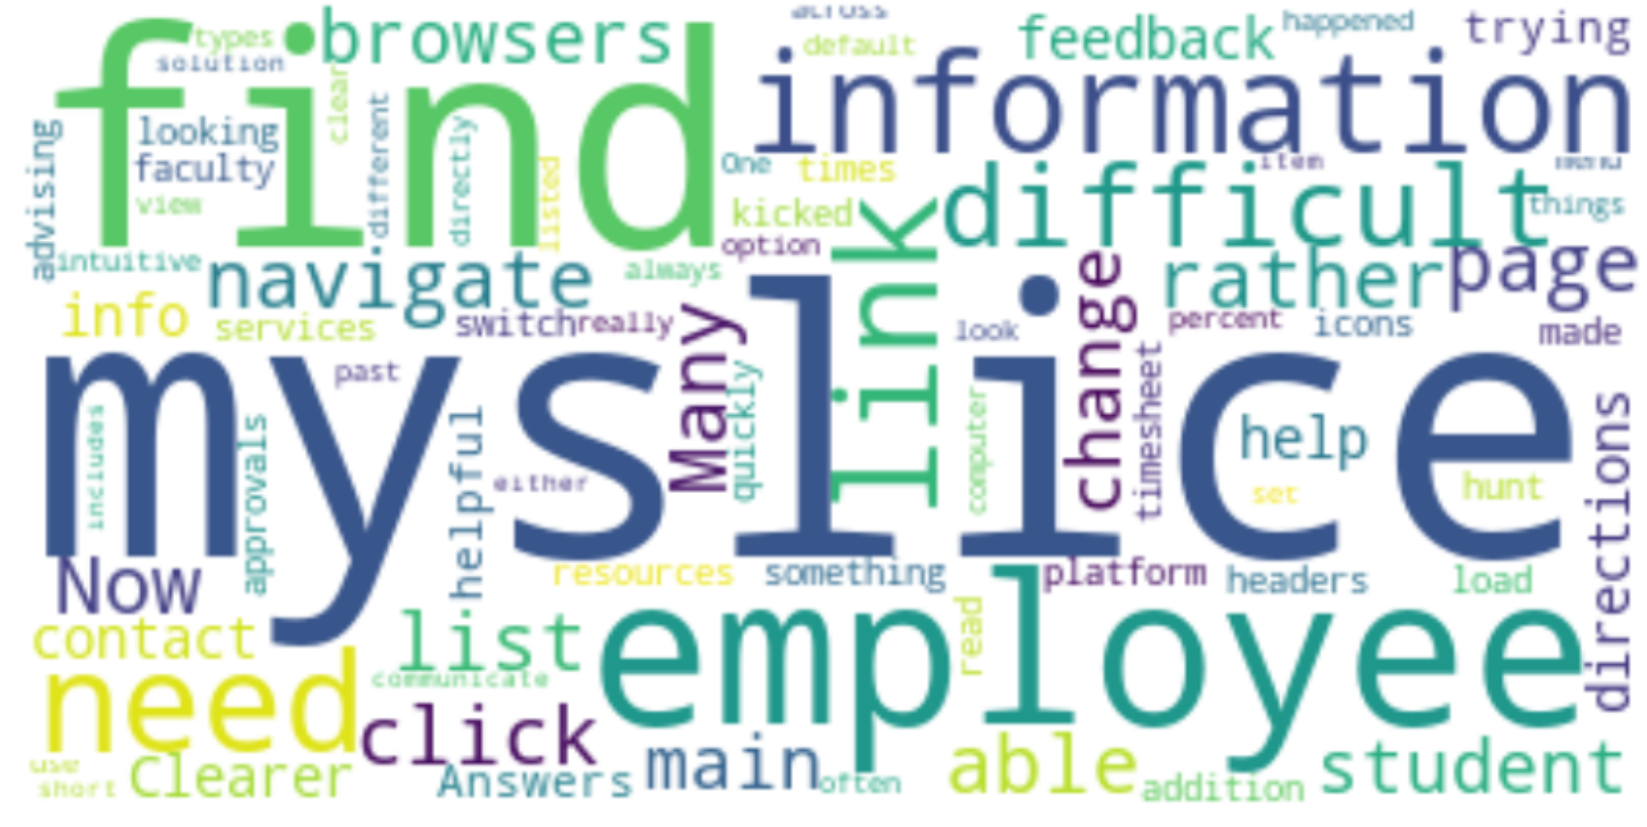 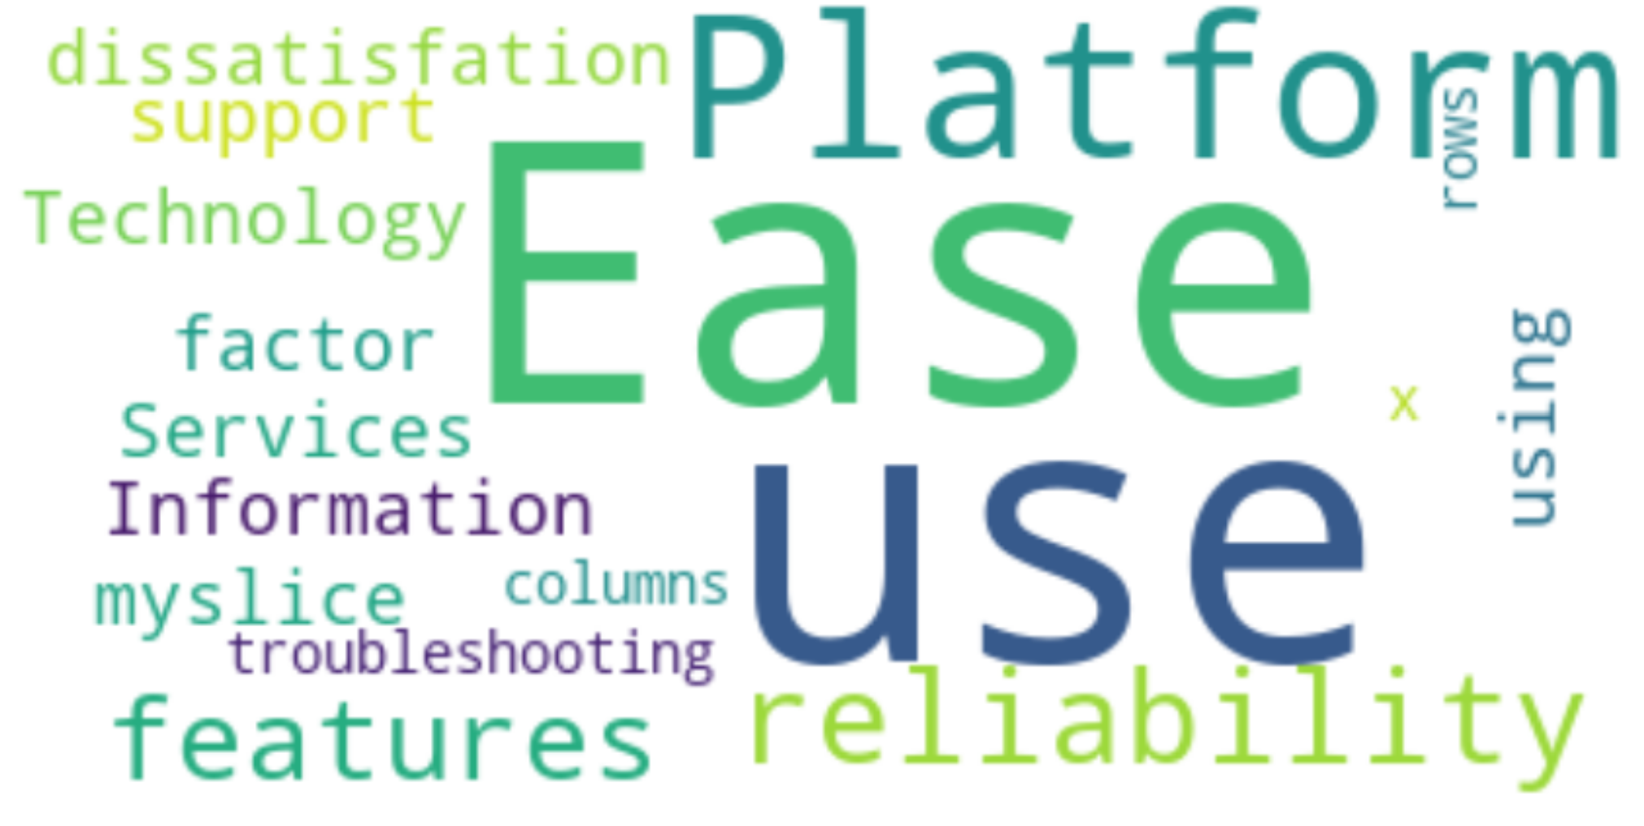 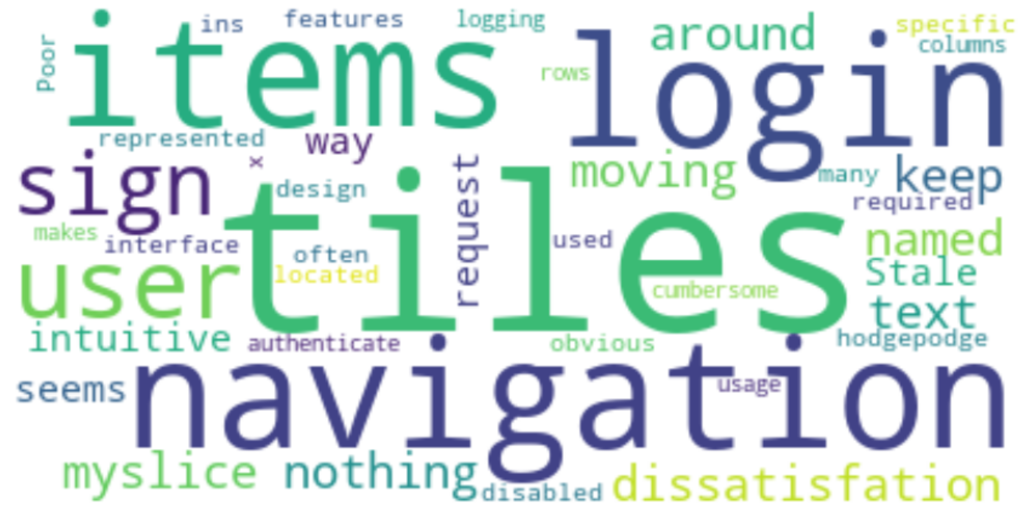

Fig 5: General Feedback – MySlice Fig 6: Dissatisfaction Factor – MySlice Fig 7: Dissatisfaction Reasons - MySlice

**4.2.B. Frequency Distribution and TF-IDF**

Analyzing the most common words in the ***myslice.feedback*** column by checking their frequency and using TF-IDF, the observation suggests that the faculty is facing a hard time using and finding information on the website.

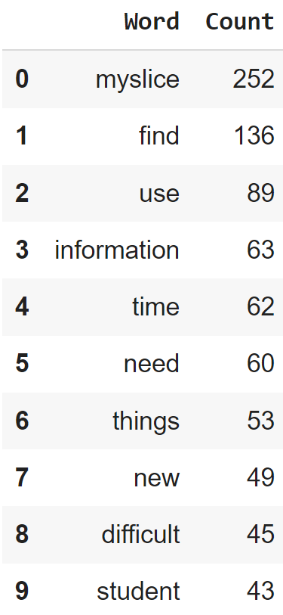 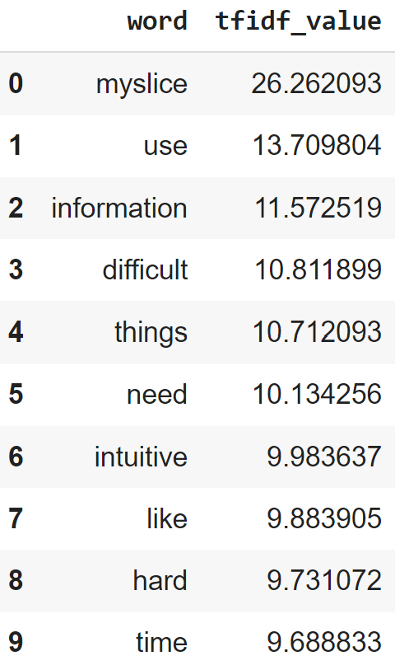

Fig 8: Frequency Distribution - MySlice Fig 9: TF-IDF - MySlice

**4.2.C. Topic Modelling**

|  |  |
| --- | --- |
| Cluster Name | Cluster Details |
| Better Navigation | Users seem to be have issues finding the menus and are unhappy about the changes made to the website.  Eg- ‘MySlice, as of its recent changes, has become more confusing and difficult to navigate.’, ‘Myslice seems very clunky and even though it has been updated’ |
| Improved Interface | Users find the new tile interface confusing and clunky.  Eg- 'I don’t use it that much, but it seems clunky.', 'The new interface with icons is visually an improvement but it can be hard to remember under which icon a given piece of information is located' |
| Reset Default View | Faculty members find the default student view of the website inconvenient.  Eg – ‘I'd really like the option to set the default page of MySlice to the Employee view.’, ‘when I log into myslice it automatically defaults to the student view’ |
| Better Communication | Users are disappointed with a lack of university wide communication when there are updates on MySlice.  Eg - 'Updates and changes should be communicated to us more often and more clearly. ', "I don't get communications about MySlice to my knowledge." |

Table 2 – Topic Modeling – MySlice

Further analysis of the reasons for the various degrees of dissatisfaction showed that the Site Layout was a major source of concern for 23% of the users. Therefore, prioritizing the reorganization of the website should be prioritized.

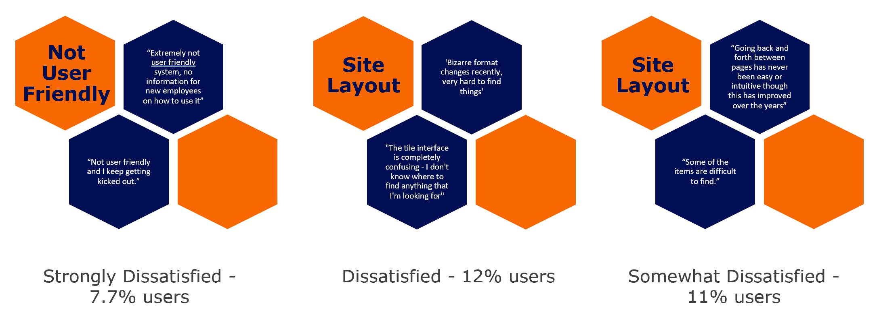Fig 10: Topic of discomfort per degree of dis-satisfaction

**4.2.D. Sentiment Analysis**

We used BERT, Word2Vec word embeddings and RoBERTa models to predict the user sentiment using the feedback provided. The accuracies of the models weren’t very high, with the pretrained model RoBERTa performing the best.

* BertClassifier – Accuracy – 30.21%
* Word2Vec – Accuracy – 34.46%
* RoBERTa – Accuracy – 55.21%

Error analysis showed that 76 feedback statements were classified incorrectly, with 95% being mis-classified as ‘Somewhat Agree’ which appears to be acting as the model’s default category. This could be due to the high overlap of common words between the 5 categories (ref Fig 10). Through this observation we would suggest that it may be better to reduce the number of degrees of satisfaction from 5 to 3 in future surveys. Since the source of discomfort is largely similar across the 3 degrees of dis-satisfaction, the higher number of subcategories seem redundant.

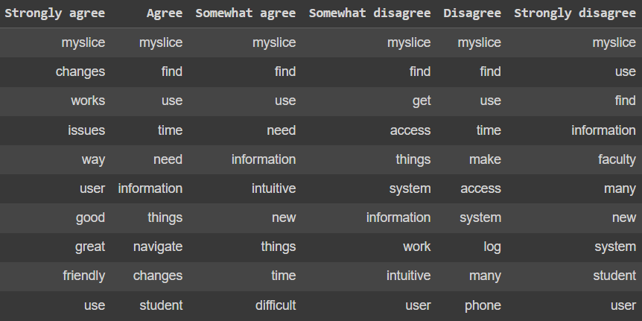

Fig 11: Word Frequencies by degree of satisfaction

**4.3 Zoom**

95% of the users were satisfied with the working of Zoom. The high level of user satisfaction resulted in a very small sample of feedback text from dissatisfied users (21 entries only). Due to that it wasn’t possible to meaningfully perform Topic Modelling or Sentiment Analysis on their feedback.

**4.3.A. Word Cloud**

Connectivity appears to be a major source of discomfort for the users.

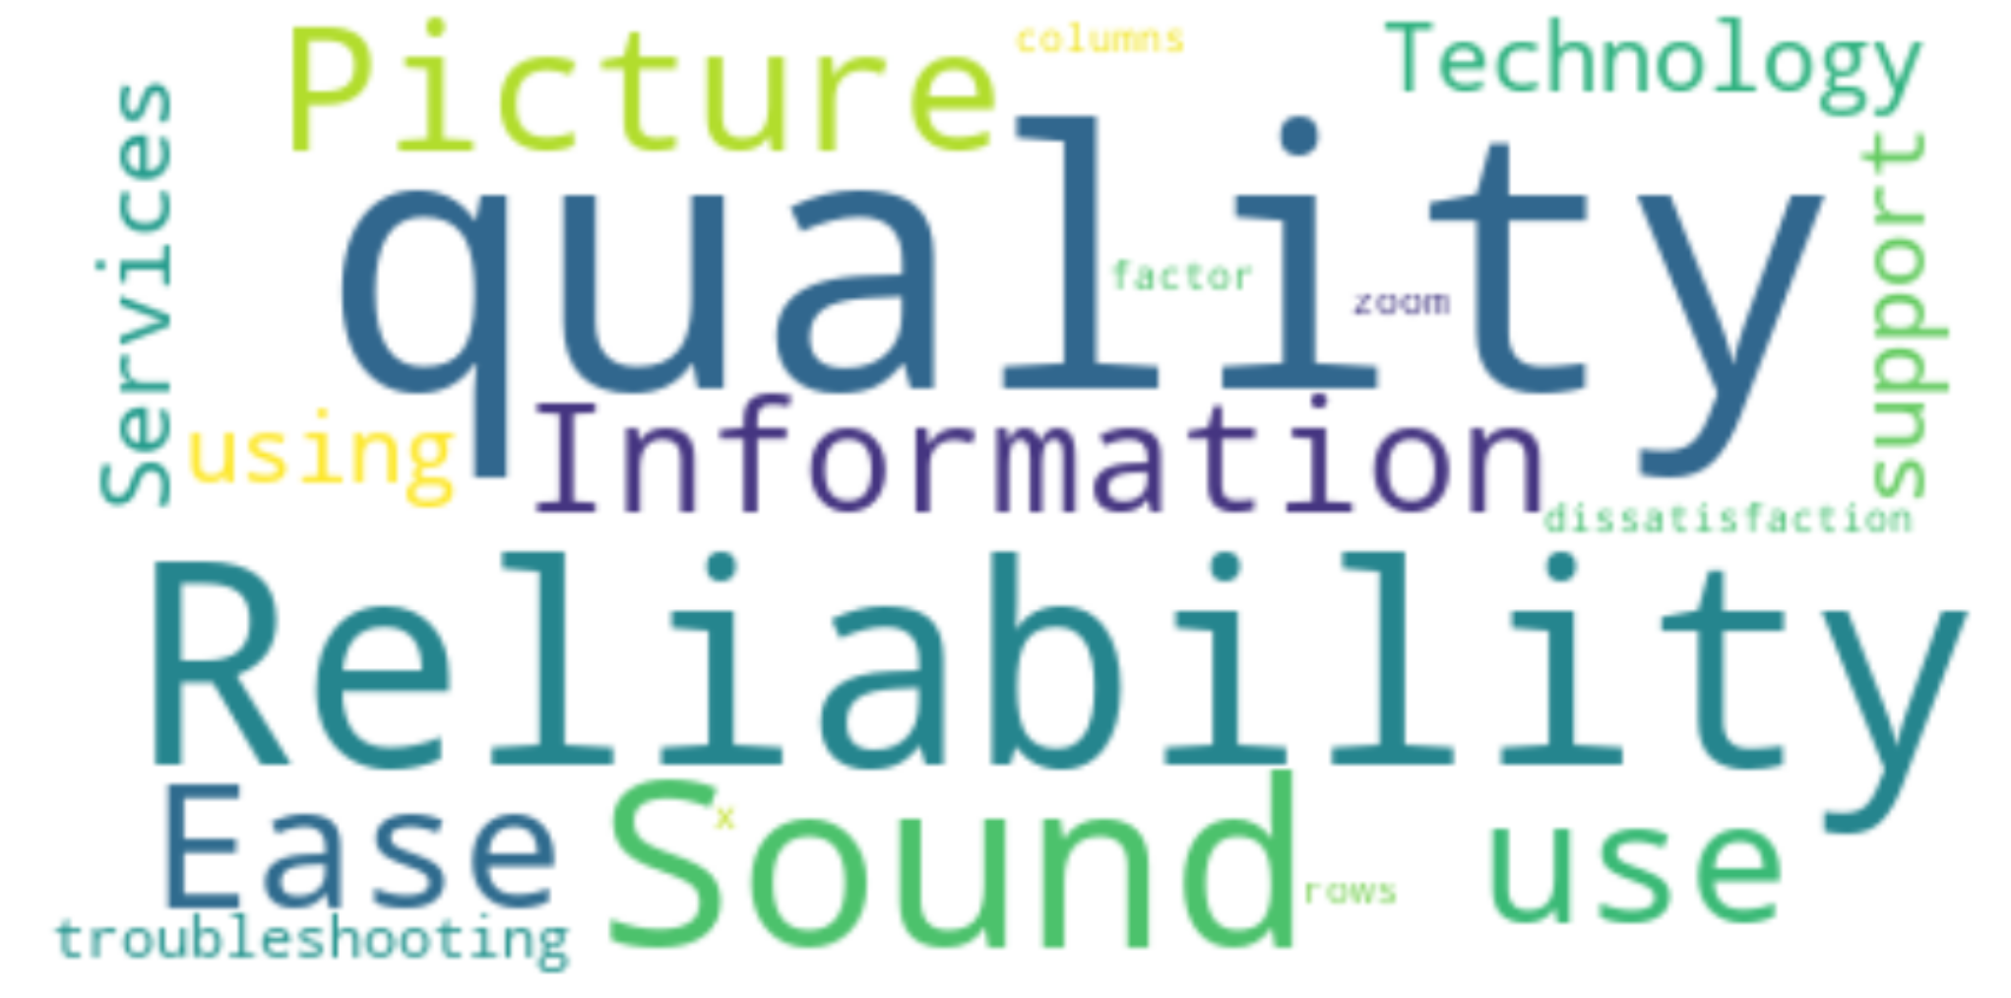 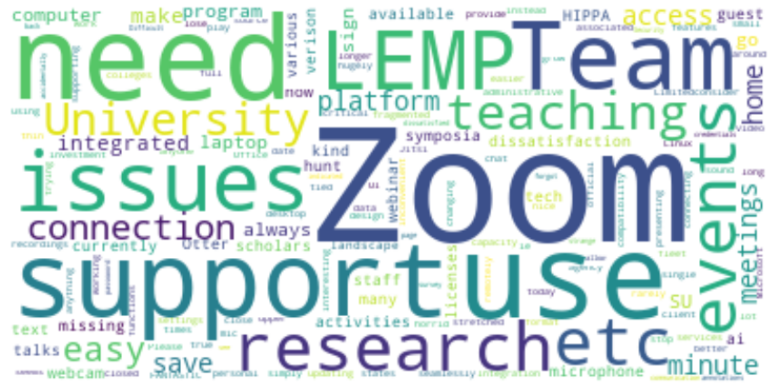

Fig 12: Dissatisfaction Factor – Zoom Fig 13: Dissatisfaction Feedback - Zoom

**4.3.B. Frequency Distribution and TF-IDF**

Analyzing the most common words in the ***zoom.feedback*** column by checking their frequency and using TF-IDF, the observation supports our inference that most users are satisfied and connectivity is the major source of discomfort.

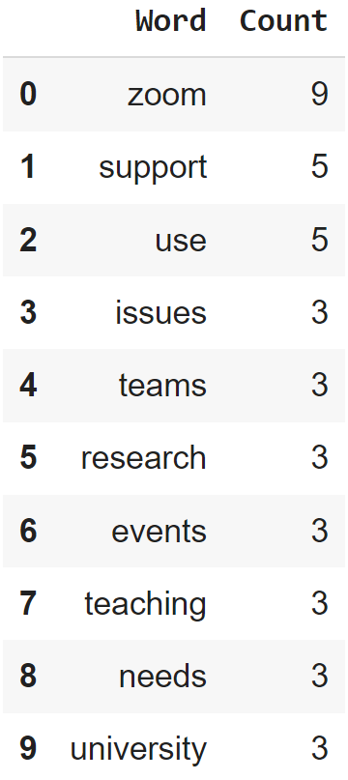 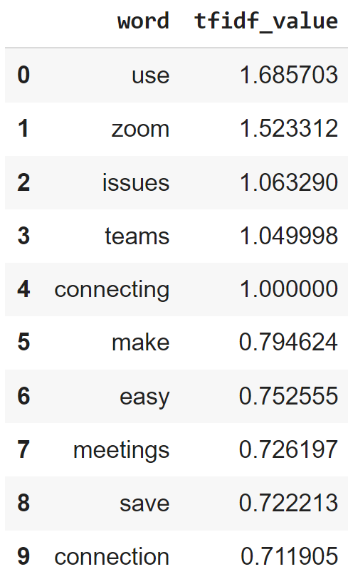

Fig 14: Frequency Distribution - Zoom Fig 15: TF-IDF - Zoom

* 1. **Teams**

80.5% of users were satisfied.

**4.4.A. Word Cloud**

Picture Quality appears to be a major factor of dissatisfaction among Teams users. Users feel it is not very intuitive or reliable. Moreover, Zoom is the preferred product which is evident from the fact that 19.5% users are dissatisfied with Teams whereas only 4.8% were dissatisfied with Zoom.

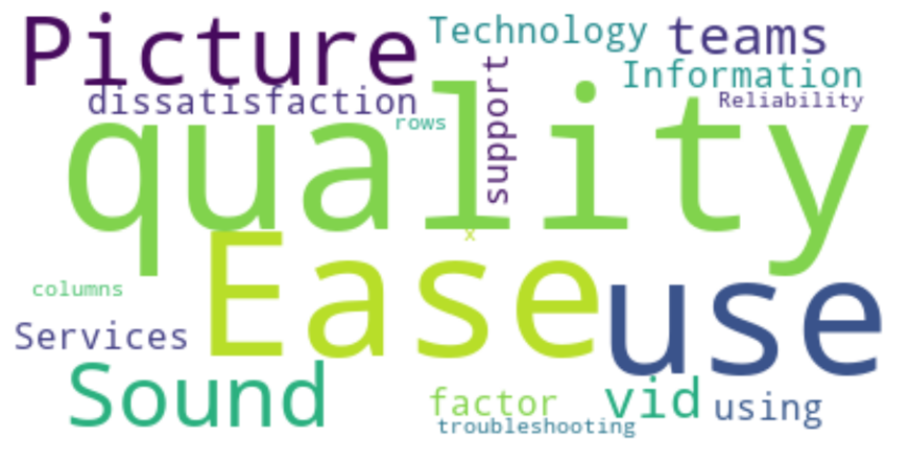 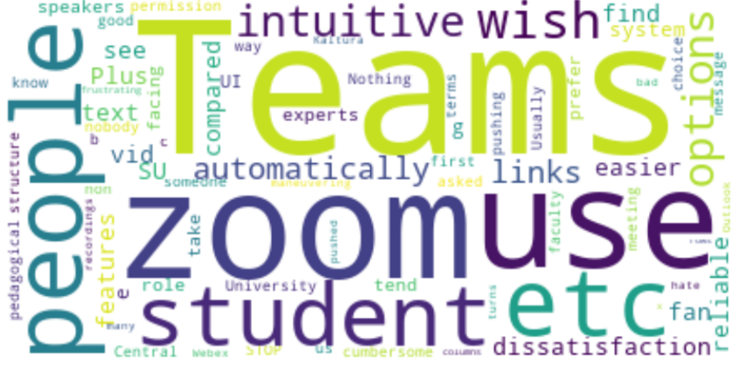

Fig 16: Dissatisfaction Factor – Teams Fig 17: Dissatisfaction Feedback - Teams

**4.4.B. Frequency Distribution and TF-IDF**

Users seem to prefer Zoom and find teams less clunky and easier to use.

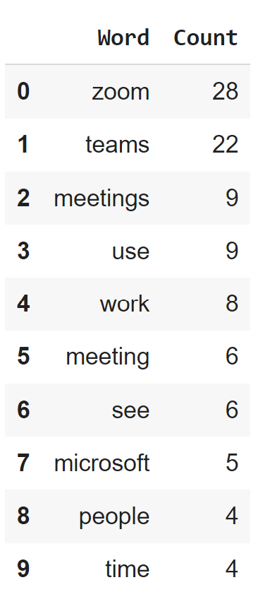 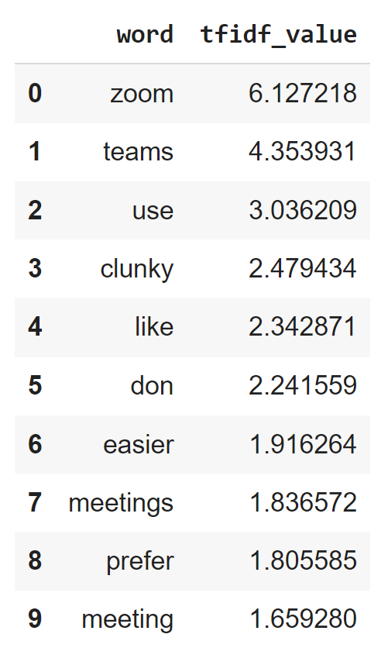

Fig 18: Frequency Distribution - Teams Fig 19: TF-IDF - Teams

**4.4.C Topic Modelling**

|  |  |
| --- | --- |
| Cluster Name | Cluster Details |
| Preference | Users seem to be more happy with Zoom as a product  Eg- “More comfortable with Zoom”, “I prefer Zoom” |
| Interface | Issues with the chat interface, screen layouts and mic.  Eg- “The mic stops functioning in the meeting. It is random and presents a problem for me as I do several presentations.” |

Table 3 – Topic Modeling – Teams

**4.5 Blackboard**

76% of the users were satisfied with Blackboard. However, there are only 17 review text which doesn’t give any concrete insight into the issues faced by the users

**4.5.A. Word Cloud**

Users find Blackboard cumbersome and not easy to use. This is further evident from the fact that users are requesting for Canvas instead as per the word cloud.

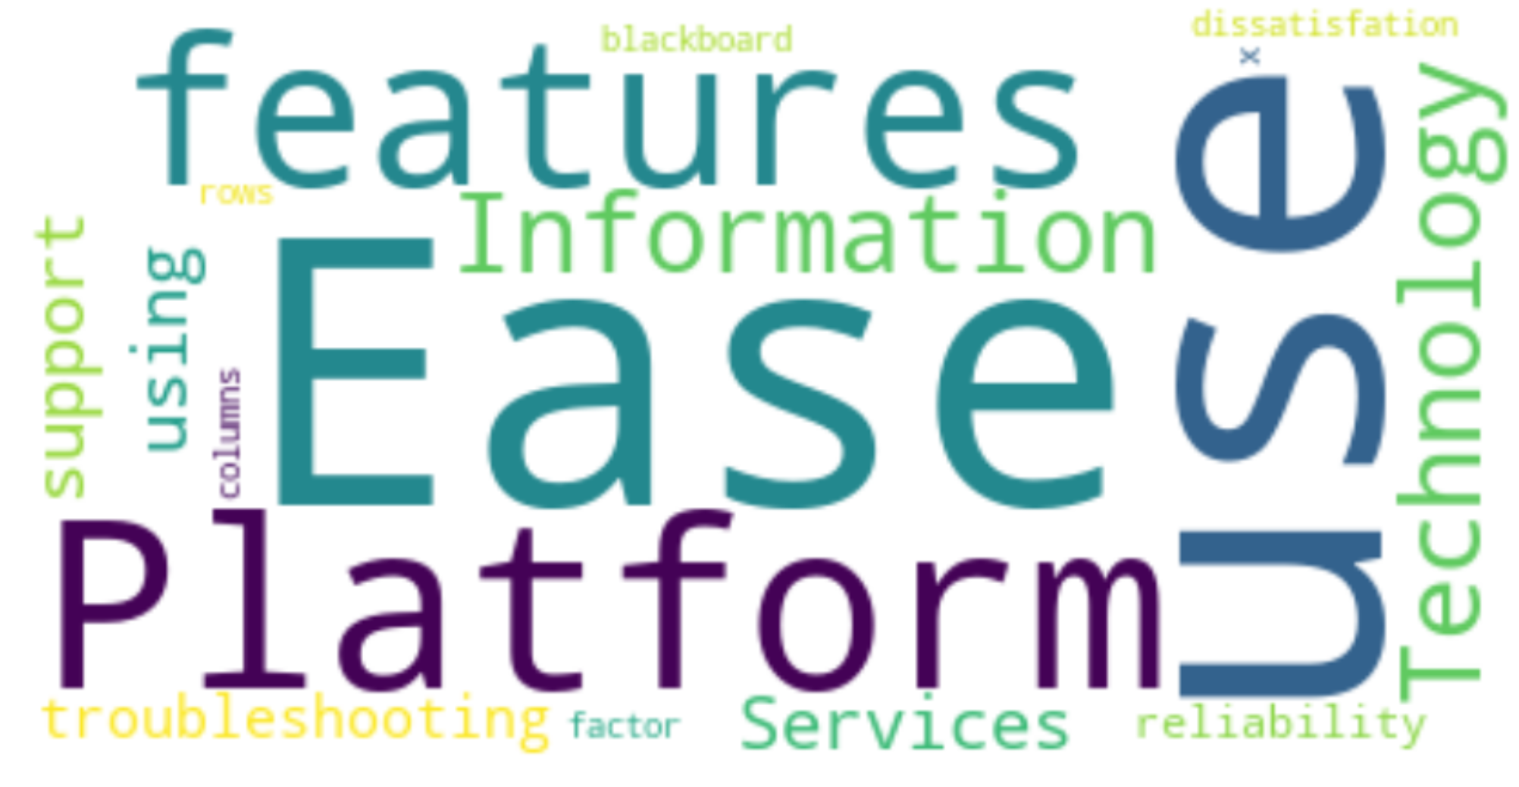 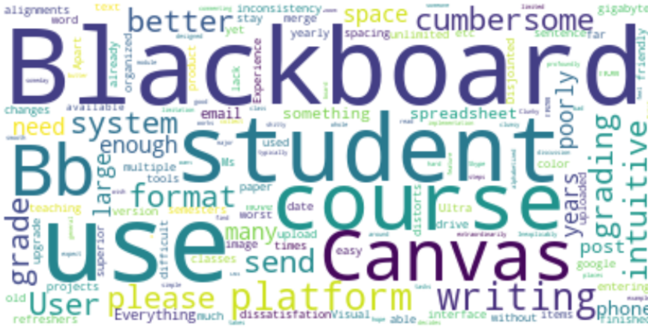

Fig 20: Dissatisfaction Factor – Blackboard Fig 21: Dissatisfaction Feedback - Blackboard

**4.5.B. Frequency Distribution and TF-IDF**

Users seem to prefer Canvas and find the Blackboard interface harder to use with a poor design.

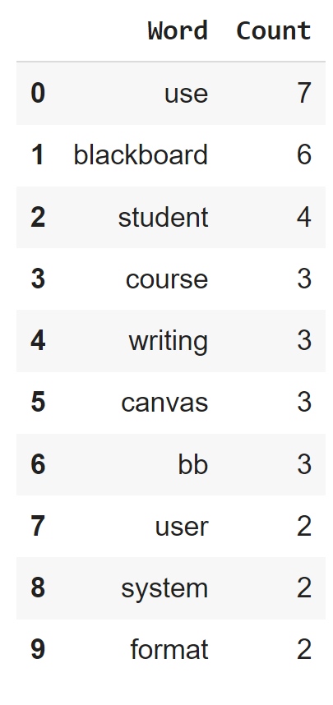 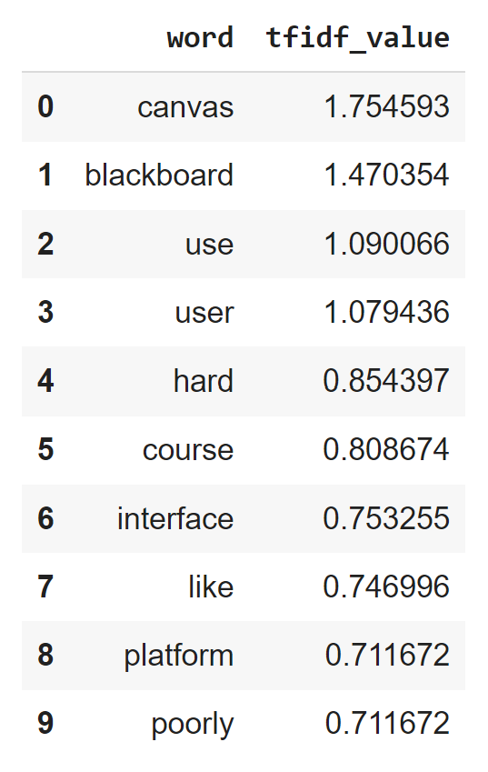

Fig 22: Frequency Distribution - Blackboard Fig 23: TF-IDF - Blackboard

**4.6 Kaltura**

93.5% of users are satisfied with this tool. Users found Kaltura useful during the pandemic and easy to use. However, there is only 1 review text which doesn’t give any concrete insight into the issues faced by the users. Since the user satisfaction rate is very high, we have not included word clouds and word frequencies in this report.

**4.7 Teaching Tools**

83% of users can find information easily regarding teaching tools, 85.8% are happy with the support and 79.8% are happy with the communication with respect to teaching tools.

**4.7.A. Word Cloud**

Blackboard is used extensively while giving feedback along with the fact that it is difficult to use. Kaltura and Playposit are also important applications which people feel require improvement.

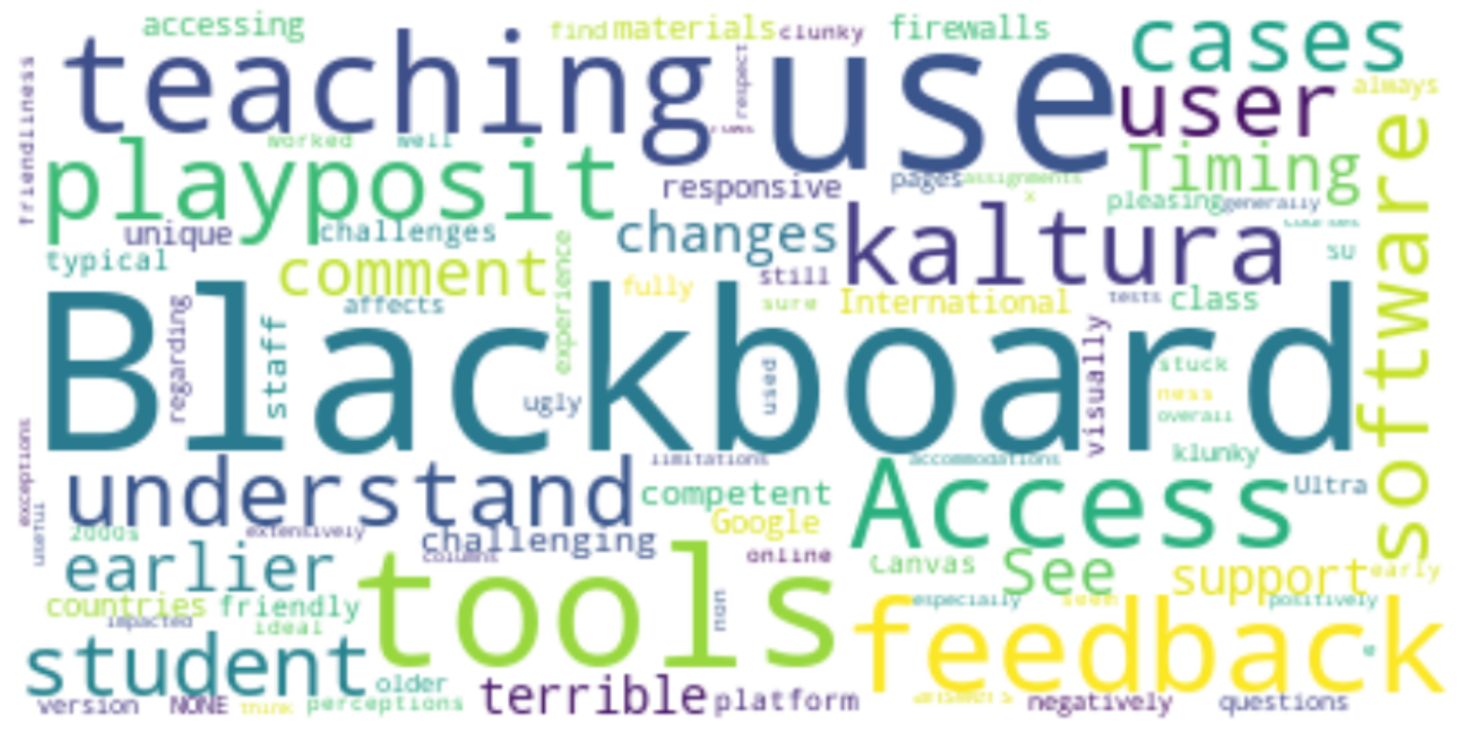

Fig 24: Dissatisfaction Feedback – Teaching Tools

**4.7.B. Frequency Distribution and TF-IDF**

Blackboard is an important cause of discomfort among the users due to the poor help and support services.

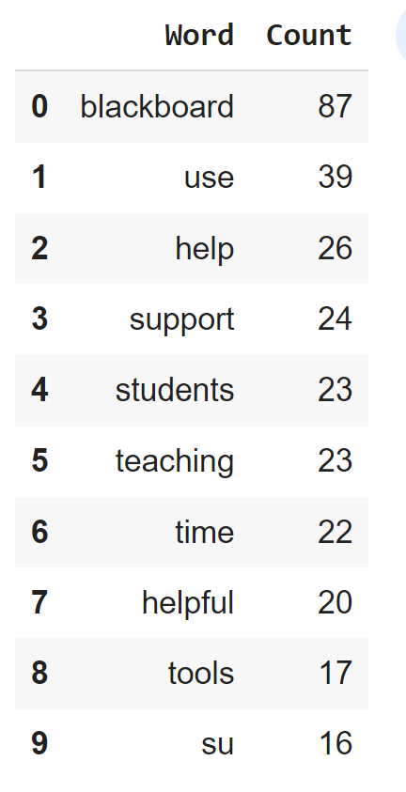 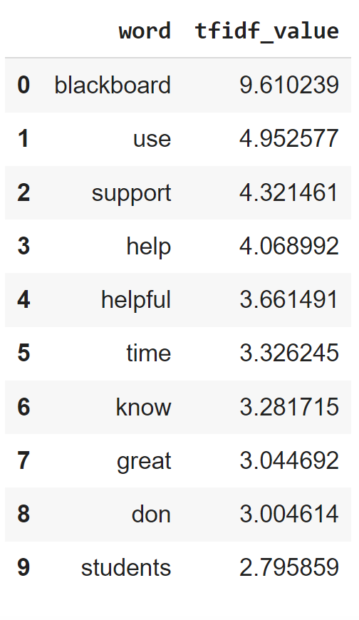

Fig 25: Frequency Distribution – Teaching Tools Fig 26: TF-IDF – Teaching Tools

**4.7.C. Topic Modelling**

|  |  |
| --- | --- |
| Cluster Name | Cluster Details |
| Blackboard | People just don't seem to like Blackboard  Eg- “I can't for the life of me understand why we're not using Canvas or some other alternative, which are infinitely better and used by our peer institutions; and why we've apparently even extended our contract with Blackboard.” |
| Login & Awareness | Issues with logging and awareness  Eg- “Sign on to the "system" with my credentials every single time I want to use Adobe in a classroom computer to show my slides...really? “ |

Table 4 – Topic Modeling – Teaching Tools

**4.8 Assistive Tools**

Looking at the survey we saw that 96.8% don’t use. There is no sentiment column but there is a column that tells us if people actually use assistive tools or not and we saw that 96.8% don’t! Out of the assistive tools, seems like Windows for MAC and JAWS for Windows are used the most. Also, the text column doesn't have feedback and the text column barely has any data hence no topic modeling could be done.

* 1. **Accessibility Feedback**

This was measured through 4 Metrics: 1) Policy Knowledge which had a user satisfaction of 78.4%, 2) Doc creation impact with a user satisfaction of 64%, 3) Aware toolkit with a user satisfaction of 58% and 4) Professional development with user satisfaction of 72%. Since there were 2 text boxes for feedback, the word cloud and word frequency were ran on both the columns.

**4.9.A. Word Cloud**

Users are having a hard time finding information, we can also see training and software are pain points.

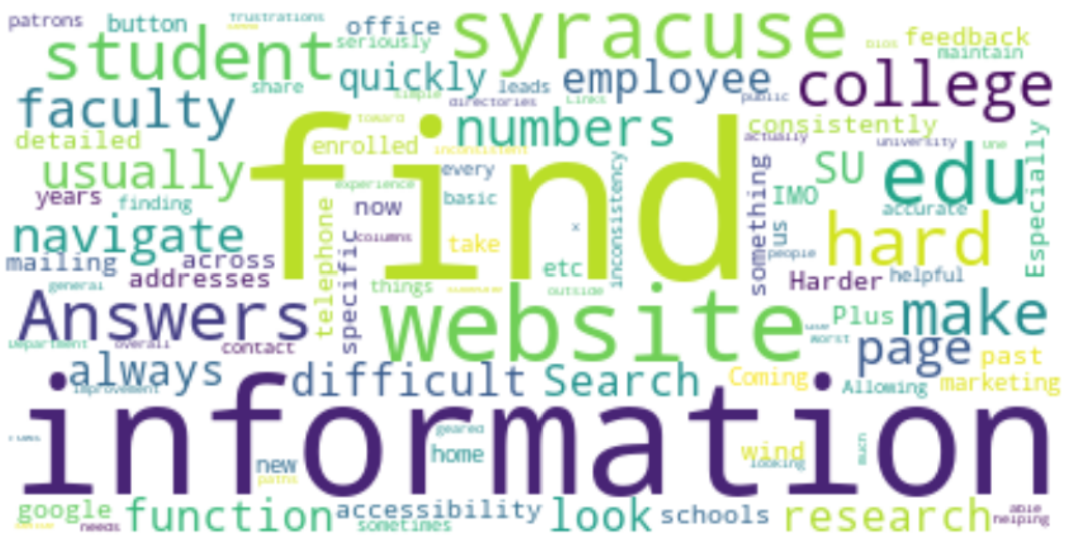 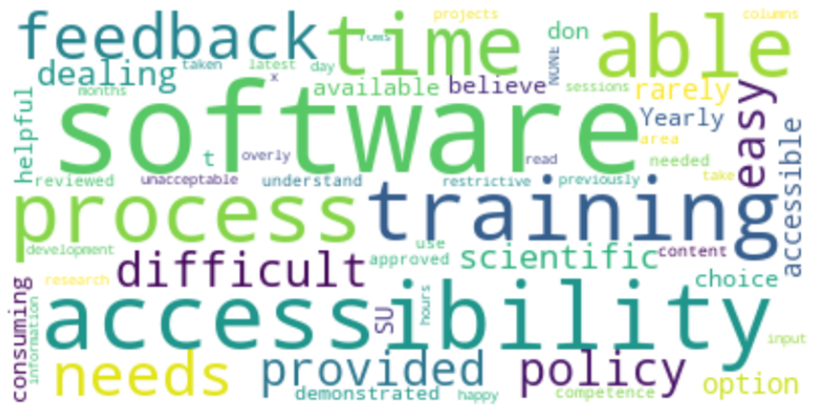

Fig 27: Dissatisfaction Feedback – Accessibility Feedback Fig 28: Dissatisfaction Feedback Text box 2- Accessibility Feedback

**4.9.B.** **Frequency Distribution and TF-IDF**

Frequency analysis shows that difficulty in finding the right information and the search feature is a source of discomfort.

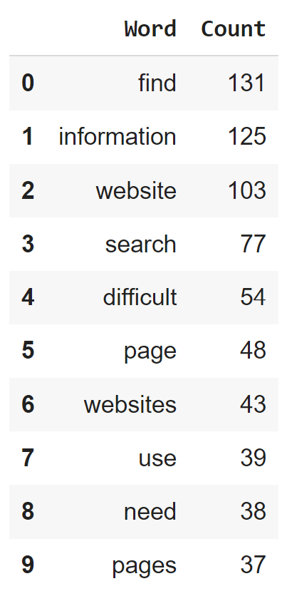 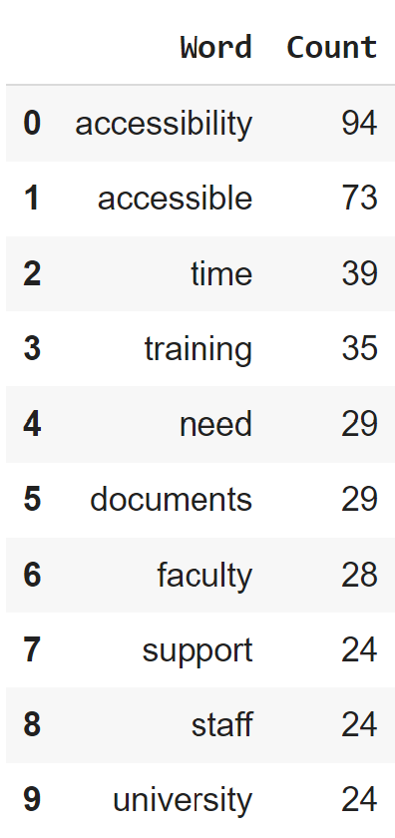 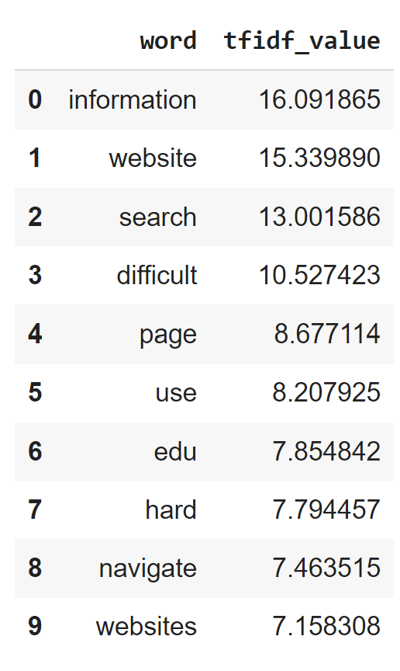 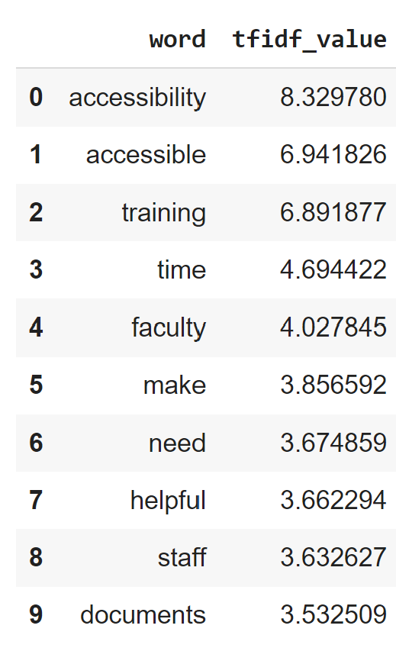

Fig 29: Frequency Distribution – Accessibility Feedback Fig 30: TF-IDF - Accessibility Feedback

**4.9.C. Topic Modelling**

|  |  |
| --- | --- |
| Cluster Name | Cluster Details |
| Search Feature | Users don’t find the search option helpful.  Eg- “Search function through the website is not always very helpful and accurate” |
| Site Layout | Users seem to have issues with the link and it had very few pictures.  Eg- "Information is hard to find, and there are very few pictures." |
| Difficulty finding Information | Users feel that the information is siloed and again not easy to find.  Eg - “It's difficult to find information because it's fragmented and not easy to find” |
| Issues with Accessibility Policy | Users are not satisfied about the accessibility policy.  Eg - “There are definite holes in the accessibility policy relating to software that does not go through a procurement life cycle.” |

Table 5 – Topic Modeling – Accessibility Feedback

* 1. **IT Challenges**

IT Challenges only had text columns names “it.challenges.text.1”, “it.challenges.text.2” and “it.challenges.text.3” so there is no percentage to how many users are satisfied with the IT services on campus.

**4.10.A. Word Cloud**

The main IT challenges faced by users seem to be with respect to computer, speed, working from home, laptop, Citrix, Linux, payroll, PowerPoint, overall updates and overall trying to resolve the issues they face.

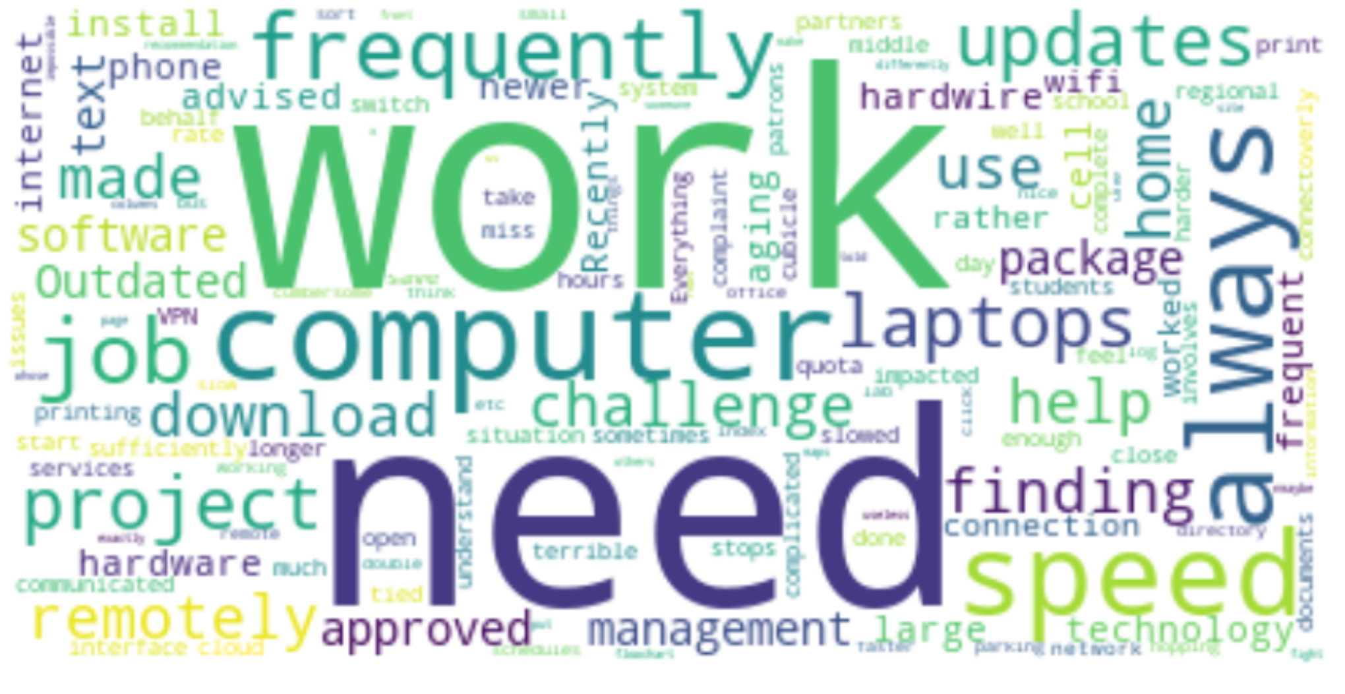 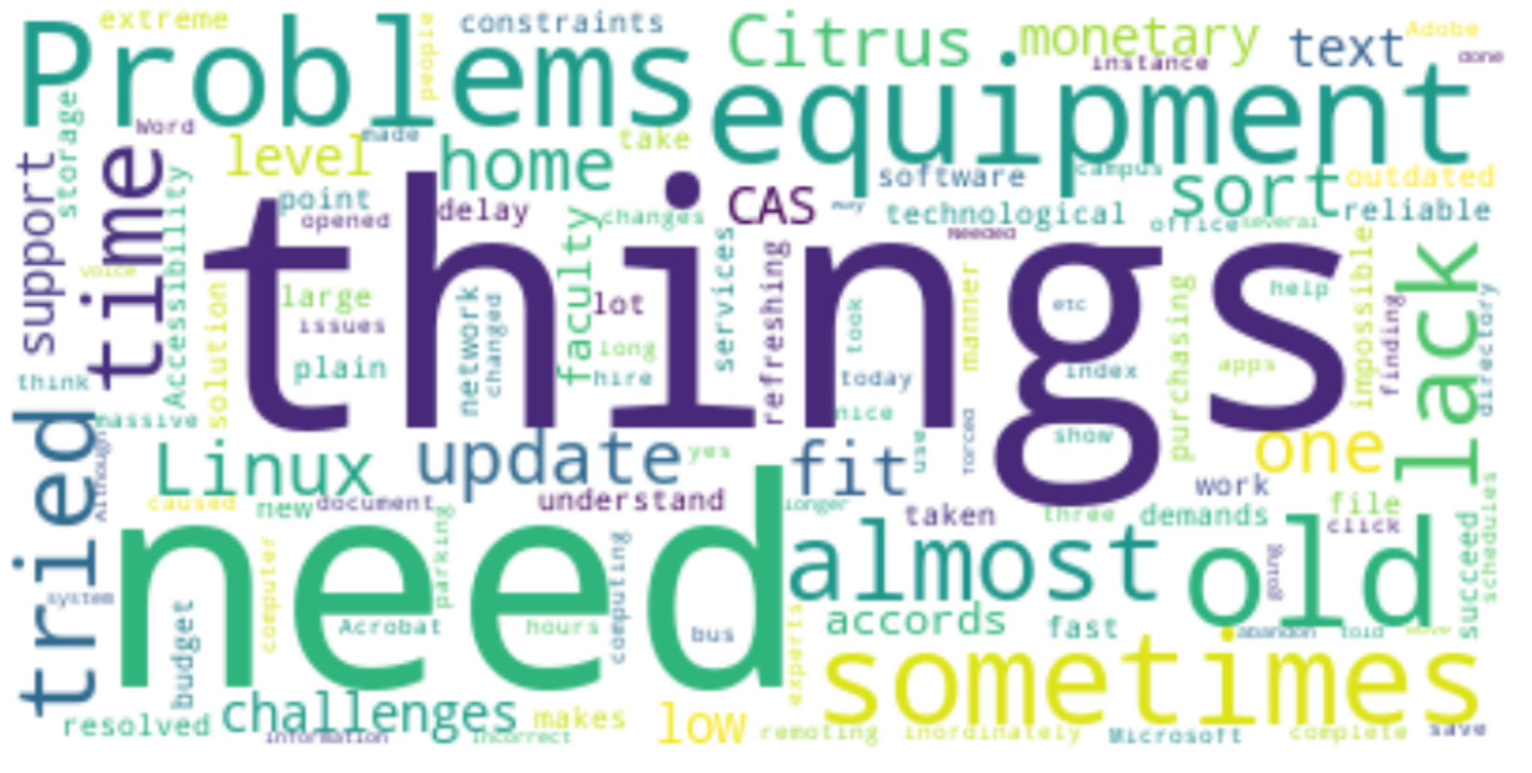 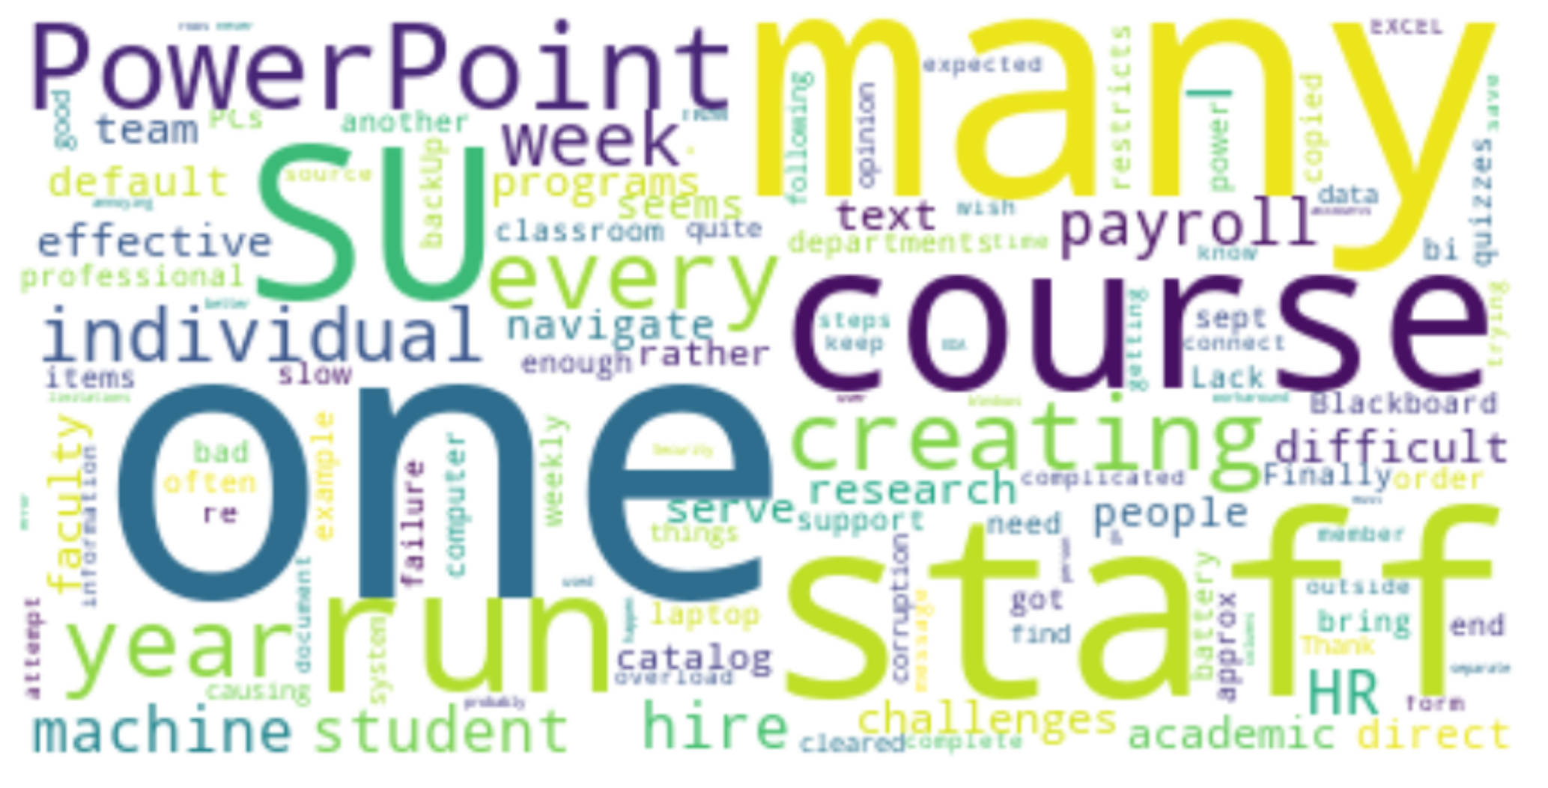

Fig 31: Dissatisfaction Feedback - Accessibility Feedback

**4.10.B.** **Frequency Distribution and TF-IDF**

Software, Blackboard and mySlice seems to be the reason for reaching out to IT services.

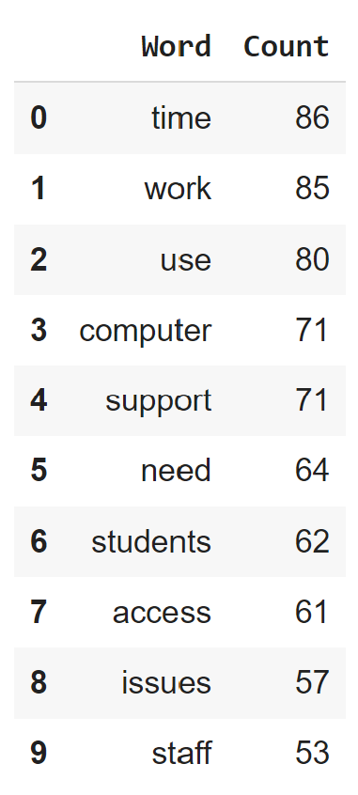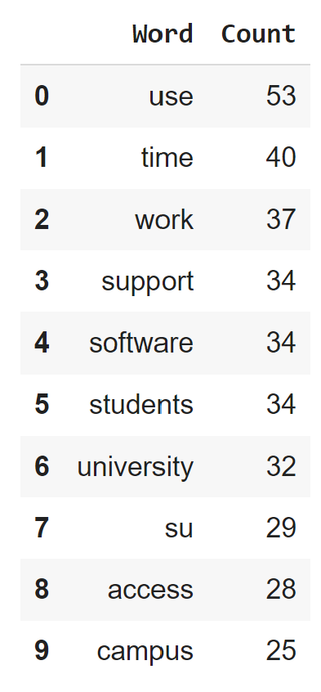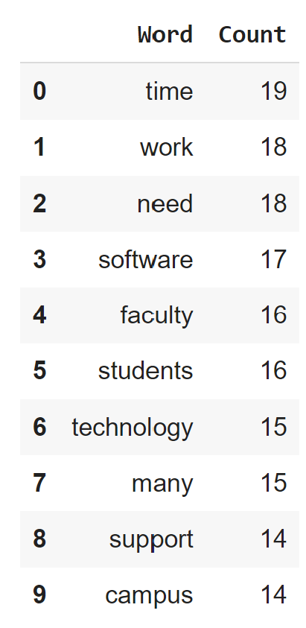

Fig 32: Frequency Distribution – IT Challenges

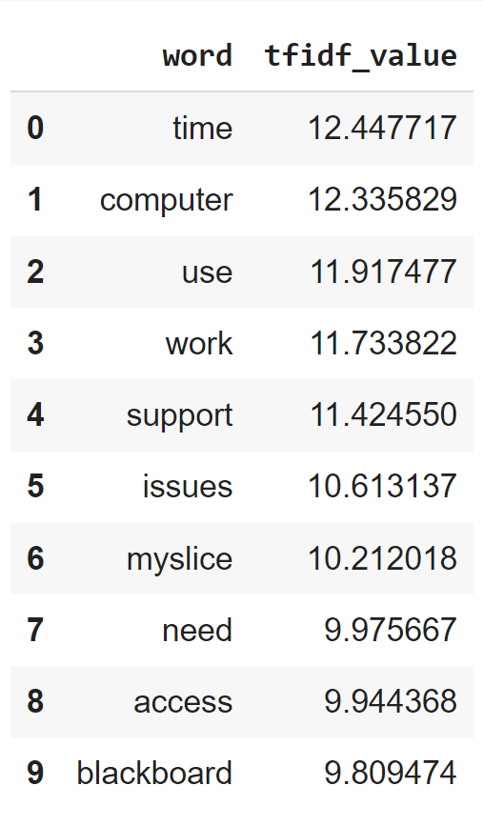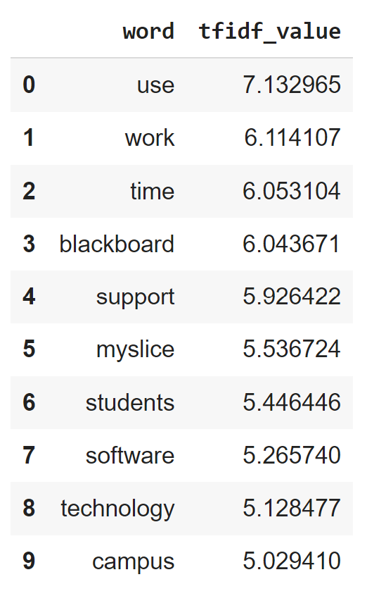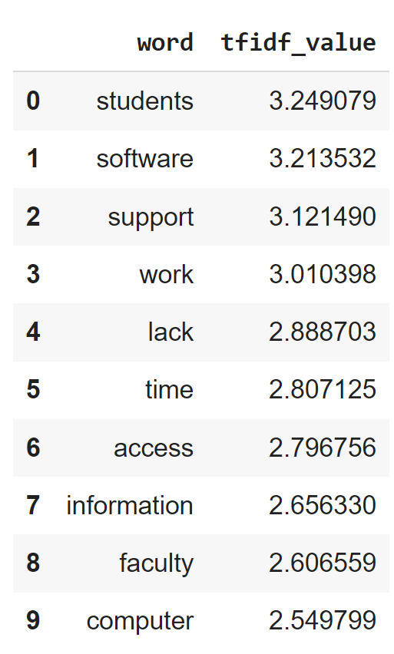

Fig 33: TF-IDF – IT Challenges

**4.10.C. Topic Modelling**

|  |  |
| --- | --- |
| Cluster Name | Cluster Details |
| Investing in support | Users feel if the support staff was paid better the support might be better and that more employees need to be brought on to support the IT challenges faced.  Eg- “ITS, along with most schools/departments are having a very hard time hiring exceptional candidates. Many of the candidates are requesting much more for salary than we can provide” |
| Answers.com | Users cant find solutions to their questions on answers.com as they find it overwhelming and time consuming or they have to dig too deep.  Eg- “It is impossible to find information in answers. you need to know exactly "answer" you\'re looking for, but I only ever have questions, so this tool is rarely helpful in a time effective manner. I always have to dig.” |
| Hardware | Hardware is difficult to update  Eg – “Outdated technology like laptops and cell phone; need more frequent updates and newer hardware” |
| Blackboard | Users are again unhappy with blackboard  Eg – “Using Blackboard. I recommend replacing it with easier to use software” |
| Accessibility Documents | Users are requesting training and documentation regarding incorporating accessibility that they can incorporate in their documents.  Eg – “Someone should be onboarded who their primary role is manage and remediate documents to meet accessibility standards” |

Table 6 – Topic Modeling – IT Challenges

* 1. **Security**

This was measured through 4 Metrics: 1) 77.65% agree that security has minimum impact on their work, 2) 86.19% users agree that there is effective communication, 3) 85.34% users know who to talk to and 4) 65.29% take the yearly training.

**4.11.A. Word Cloud**

The word cloud shows that computer access and password are issues with respect to security.

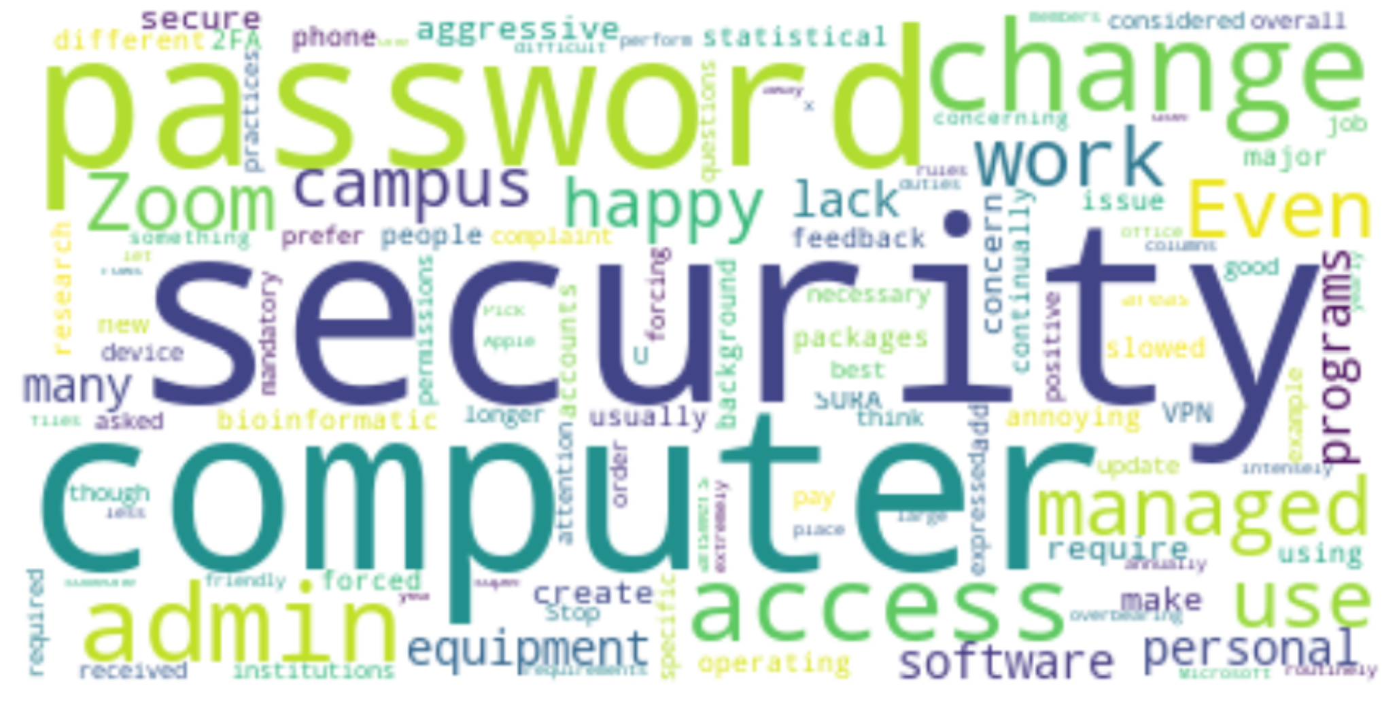

Fig 34: Dissatisfaction Feedback – Security

**4.11.B.** **Frequency Distribution and TF-IDF**

Analyzing the most common words by checking their frequency and using TF-IDF, training, access, password appears to be a major source of the trouble.

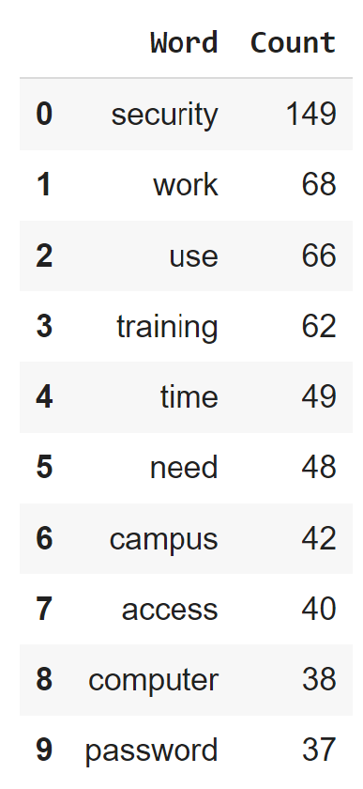 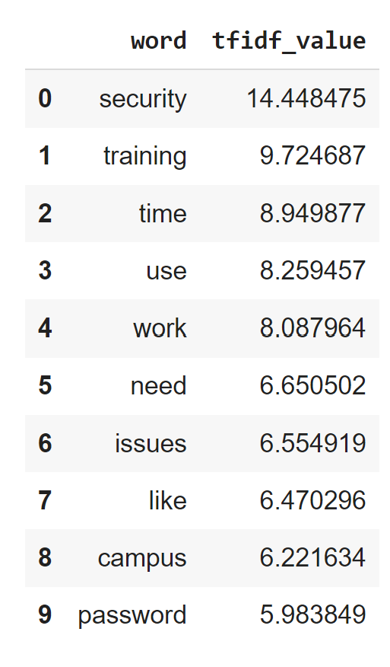

Fig 35: Frequency Distribution -Security Fig 36: TF-IDF – Security

**4.11.C. Topic Modelling**

|  |  |
| --- | --- |
| Cluster Name | Cluster Details |
| Training & Login | Training with respect to security is necessary and logging in using Authenticator App and RDS is hard  Eg- “It's nice to hear about new types of cyberthreats; I'm not sure that needs to be shared in an actual training, but that's just my opinion. I'll do what I'm asked to do with it.” |

* 1. **Playposit**

88.09% users are happy with the software and since there was only one feedback which states “Clunky” there was no need of any other analysis for this tool.

**4.13 Google Suite**

96.15% users are happy with the software and given the high satisfaction rate and that there were only 2 responses recorded for dissatisfaction, no further analysis was needed for this tool.

**5. Ethics Statement**

Since we didn’t have any personally identifiable information regarding the survey and the fact that this survey will help improve the experience of users, there are no ethical concerns.

**6. Conclusion**

Below are the insights and recommendations (in italic) we have based on the data we were provided for this survey:

1. Blackboard seems to be the tool that most users are unsatisfied across the feedback such as IT challenges, Teaching Tools. They would *prefer to use Canva*, are not happy with the UI of the tool and find it hard to grade on the tool.
2. Another tool that users are highly unhappy with was MySlice. They are unhappy with the UI, the fact that they need to re-navigate to a page again and again, have to see the student page first and then navigate to the faculty page each time and would *prefer to be able to bookmark or customize the UI* to better suit their needs and are highly unhappy with the stale login issues faced. Unhappiness for this tool was again seen across multiple tools feedback.
3. *Troubleshoot and see if the bandwidth for wireless network is tested for classrooms in Life science building and near college place bus stop.*
4. People have a hard time finding information regarding accessibility and *would like to have someone dedicated to this cause so that they can incorporate the policy in their work such as marketing & business presentations*
5. Users find Answers.com confusing and cumbersome to navigate.
6. Users would like a bigger team for the support staff and have recommended to *either increase the salary of the support staff or hire more people* to get their queries answered sooner.

**7. References**

* <https://medium.com/@piocalderon/vader-sentiment-analysis-explained-f1c4f9101cd9#:~:text=VADER%20sentiment%20analysis%20combines%20a,movie%20reviews%20and%20opinion%20articles>.